School of Sport and Recreation

Department of Coaching, Health and Physical Education

Constraints Practical

Theory into Practice Activity - Task Constraints

The following is an idea of how constraints could be changed in a practical setting. Also provided are discussion questions that could follow each activity to enhance learners understanding.

NB. Please change the context to suit.

- Phase 1

Whole court basketball with half class vs half class ie. 15 v 15. No specific rules apart from basics of basketball such as double dribbling etc.

- Phase 2

Manipulate the dimensions of the court and scoring options. For example if you have a gym which also has across court hoops, make these scoring options also (see diagram below). If you like you can add points to these options such as 1 point for basket in end court hoop, 3 points for basket in side court hoops

1 pt

3pt 3pt

3pt 3pt

1pt

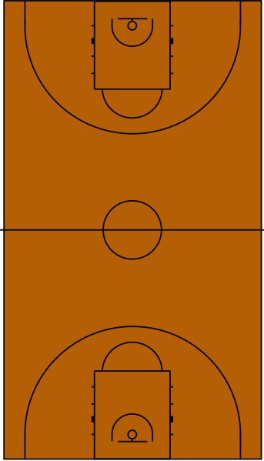

Discussion - how did manipulating the constraints of the task change how your team played? What did you notice and what was the difference between Phase 1 and Phase 2? Was this change desirable and why? How did players move differently?

(NB. key ideas might be that swarming of the ball was less prominent in Phase 2 game. Players may have spread the ball wide to take the 3-point option and therefore had more space on court and did not all just charge up the middle)

- Phase 3

If you have side hoops, now divide in 2 smaller sided games going across the gym. Eg. 7 v 7. 2 ‘scoring players’ are positioned along each sideline at the scoring end for each team (similar positioning to where a side hoop might be). As in the previous phase, 1 point will be scored for end basket, and now 3 points will be scored if the ball gets passed to the ‘scoring player’ on the full.

Discussion - what happened when the task was changed to have less people on the court? What did you observe / experience in terms of different ways you may have moved compared to previous games where there was 15 in each team? What did you notice about the way you or others moved in relation to preventing 3 points being scored against you? Did you notice any individual constraints that affect the different ways we move, or our levels of success?

(NB. key ideas might be how swarming was now even less given the lesser number of people and hence the creation of space. People may now have felt more confident to carry the ball for longer without panicking and throwing the ball away as less ‘swarmed’ by others, passes may be been more accurate given space and ability to see options, there may have been more variation in passes given more space and time to try ‘riskier’ passes, people may have started to either space or man-on-man mark to try and limit the 3 points therefore opening up awareness of both attacking and defending roles in the game. In regard to individual constraints they may have recognised ‘skill’ level and the transfer of existing movement patterns if players had previously played netball or basketball, they may have picked up advantage of tall players to either intercept/defend the 3 point scoring option or to create opportunity if the tall person was the ‘scoring player’)

- Phase 4

Re-group the 4 teams into teams where you as the teacher have observed similar emerging movements. The teacher can modify the task to ensure it meets the needs of the individuals on the courts. For example if a group is organised due to their preference to ‘always just dribble down the court and not play as a team’ the task can be manipulated to encourage passing eg using flat balls if basketball, 5 passes before scoring etc. The teacher needs to be able to recognise what movement patterns they want to develop / encourage.

Below are some examples of what you could do:

- Defending team has to retreat to their defensive half when opposition has overturned possession and cannot try to regain possession until over half way : to encourage and develop confidence in ball carrying / dribbling
- Use flat balls: to encourage a passing rather than a dribbling game
- Must make at least 3 passes before shooting: to encourage passing in a team that has ball hogs or dribbles and loses possession lots.
- Extra point if pass to sub on sideline who makes successful pass back into own team: to encourage looking wide and opening up the game instead of always up the middle
- Different points for shots dependant on what you want eg. for in key / out of key / under basket: to encourage taking risks in trying a variety of shots depending where opposition are
- Put players in certain areas that they must stay in eg. tall players X2 - 1 under each basket (defending and attacking), 3 players who play in vertical zones up the court ro horizontal zones depending : to encourage / exploit individual constraints eg height under basket, speed/control to dribble up the court and pass wide (vertical zones), ability to switch from ball carrier to attacking / defending mode (horizontal zones) : to utilise individual constraints

Discussion: how did manipulating the constraints of the task change how your team played? What did you notice and what was the difference in the way people moved? Was this change desirable and why?

