Antoine’s range
Renowned chef patron Tony Astle (he and his late wife Beth owned fine dining restaurant Antoine’s in Parnell), is releasing a range of gourmet foods with all profits going to AUT’s Student Support Fund. View the promotional video. Tony and AUT culinary students have been busy cooking up a storm. Enjoy classic dishes from the Antoine’s menu. It’s as simple as…just reheat and eat! A QR code on each product is linked to a ‘how to best reheat’ video.
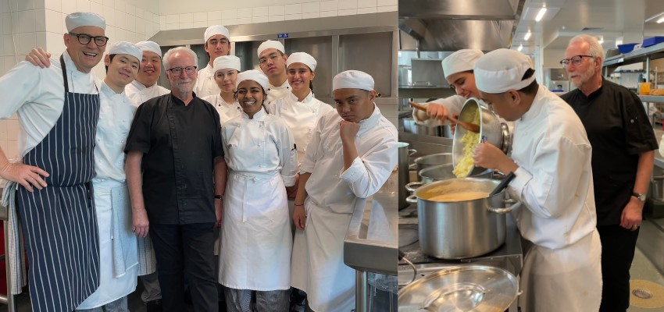

Copy and paste the order form below into an email, fill it out and send it to lindsay.neill@aut.ac.nz
You can collect your order or purchase on the day at Piko, 11am-12 noon Wednesday 15 November. If this time does not suit, please contact Lindsay to arrange an alternative time.
Be quick, these products will be retailing soon, be in first at our best pricing.
Each dish contains 2 portions. The vichyssoise contains 4 portions (with the addition of 250ml cream or milk). The tripes and vichyssoise are sold frozen. Note: The Duck a l’orange is best served together with the Orange Duck Sauce.
NAME:
PHONE:
EMAIL:
Dish | Unit Cost  Includes GST | Quantity | Your Total Cost
Antoine’s Vinaigrette | $9.75
Antoine’s Vichyssoise | $23.00
Antoine’s Classic Tripe | $38.00
Antoine’s Spicy Asian Tripe | $38.00
Antoine’s Duck a l’orange | $45.00
Orange Duck Sauce | $8.50
Total cost

