School of Sport and Recreation

Department of Coaching, Health and Physical Education

Learning through rewards - student activity

Using the links below look at one of the four theorists and answer the questions.

Pavlov - https://www.youtube.com/watch?v=k3KSpeiRPTc  Big Bang Theory - Sheldon conditioning Penny https://www.youtube.com/watch?v=qy_mIEnnlF4 | Skinner - https://www.youtube.com/watch?v=ZpSxJw0BFZs&t=97s

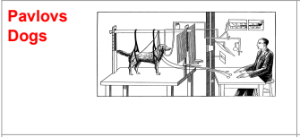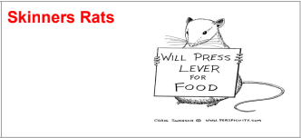

Watson - https://www.youtube.com/watch?v=FMnhyGozLyE&t=2s | Thorndike - https://www.youtube.com/watch?v=BDujDOLre-8

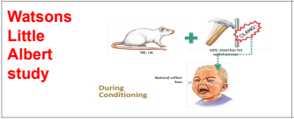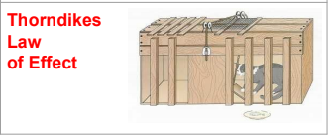

- When did your theorist complete their study?
- What did they do for their study?
- What were the main points to come out of their study? How did they explain the way we learn?

